Christmas Checklist: Gift Wrapping

BEST PRACTICES
- Get the right gear: We recommend a T-square to make straight cuts across wide swaths of wrapping paper; a rotary cutter for quick, even cuts; a self-healing cutting mat to protect surfaces; double-sided tape; and a clear quilting ruler for alignment.
- Make a Gift-Wrapping Station: A pegboard affixed to a wall or the back of a door makes for a great way to keep your supplies organized and your process streamlined.
- Wrap as you buy: You can always add ribbons, bows, and tags later. Label presents with sticky notes so that you don't forget who the recipient should be.
- Color code: If you have a lot of gifts per family member, assign each individual a different color wrapping paper. This way, you don't need gift tags!
- Recycle your wrapping: Run old wrapping paper through a shredder and reuse it as filler in gift boxes or bags.
- Stock up from sales: The days following Christmas are the perfect time to stock up on paper and trimmings for next year.

HOW TO WRAP A PRESENT
Step 1: Before you cut into your gift-wrapping paper, make sure it's the right size. When you wrap the paper around lengthwise, the edges should overlap by a few inches and the open sides should reach a bit more than halfway up the height of the gift when folded over. | 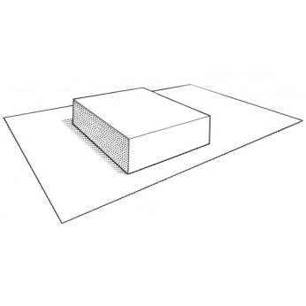
Step 2: Once you have your piece of paper, place the box in the center of it, top down. Fold one side over the top until the edge of the paper is about three quarters of an inch from the other side of the box. Then pull the other end of the paper over the box until the paper is nice and taut. Secure with tape (for neat, unwrinkled edges, we suggest double-sided tape). | 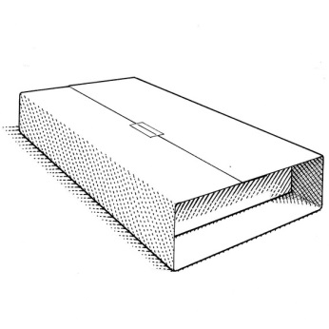
Step 3: With one open end facing you, carefully fold in one side flap. Make sure all the corners are taut and neat. Secure with tape. Repeat with other side. | 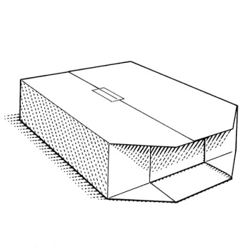
Step 4: Fold down the top flap. For an extra clean edge, fold in the bottom quarter inch of the flap before securing with tape. | 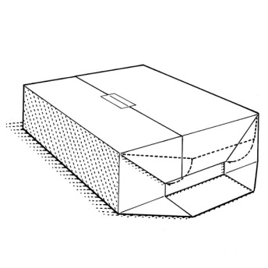
Step 5: Fold up the bottom flap and secure with tape. Repeat steps 4 and 5 on the other side. | 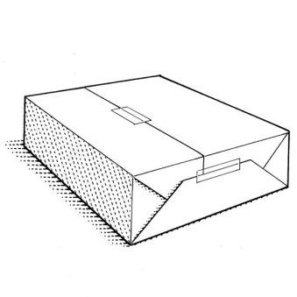
(Bonus tip: If you're wrapping something soft, such as a sweater or scarf, without a box, cut a piece of cardboard to size and place the garment on top. The base will help you make clean corners and keep the paper from tearing or wrinkling.)

HOW TO TIE A BOW
Step 1: Tie the ribbon lengthwise around the box -- don't knot. Pulling the ribbon taut, turn the box so that the ribbon now runs the width of the box. Wrap around, flipping the box as you go so that you end up back at the top of the box. Use the ends of the ribbon to create two equal-sized loops at the center of the box. | 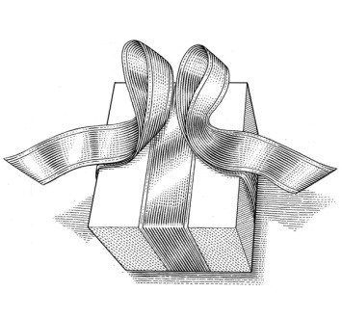
Step 2: Cross the right loop over the left loop. | 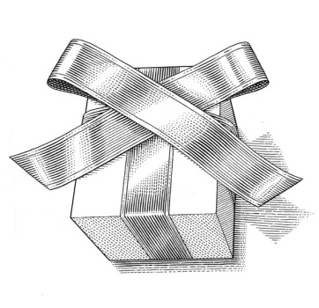
Step 3: Then bring it behind and under the loop that is now pointing to the right. This should form a knot. Make sure you haven't ventured too far away from the box.
Step 4: Fold the ribbon that is pointing to the right back over so that it points to the left again. Bring the loop that's pointing downward up and over the front. | 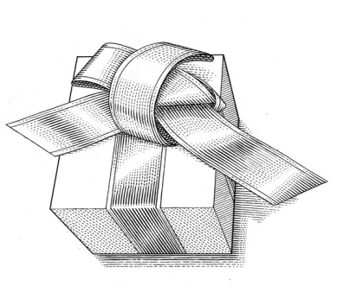
Step 5: Find the front-most hole in the center and slip in your loop. Pull the knot snugly. | 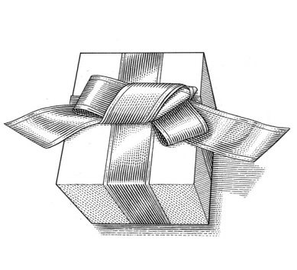
Step 6: Finish the bow by adjusting the loops and the tails, then trimming the ends of the tails until they are the same length. To prevent fraying, notch the ends or trim them with pinking or scalloping shears. | 