BRUSSEL SPROUTS w/ BACON
COOK TIME
Prep | 15 m
Cook | 25 m
Ready In | 40 m

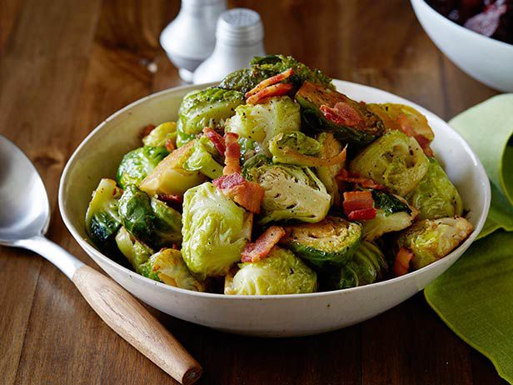
INGREDIENTS
1 1/2 pounds fresh Brussels sprouts
8 slices bacon
1 teaspoon butter
2 teaspoons olive oil
4 cloves garlic, chopped
1/2 cup reduced-sodium chicken broth
1/4 teaspoon salt
1/8 teaspoon ground black pepper
2 teaspoons butter
DIRECTIONS
Cut an 'X' in the core end of each Brussels sprout. Set sprouts aside.
Place bacon in a large skillet and cook over medium-high heat, turning occasionally, until evenly browned, about 10 minutes; drain and cool on paper towels. Crumble.
Heat 1 teaspoon butter and olive oil in a large skillet over medium heat; cook and stir garlic until golden brown, 3 to 5 minutes. Add Brussels sprouts; toss to coat. Stir in broth, salt, and black pepper; cover and cook until Brussels sprouts are tender, 12 to 14 minutes. Drain liquid from pan.
Stir remaining 2 teaspoons butter into Brussels sprouts mixture until melted. Mix in bacon and serve.

