 | BUTTERED ROLLS
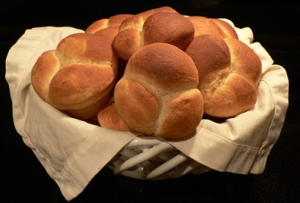 | COOK TIME  Prep 25 m  Inactive 4 hr 10 m  Cook 25 m  Ready In 5 hr
INGREDIENTS
 | 2 cups plus 2 tablespoons milk
 | 7 tablespoons unsalted butter, plus more for the baking dish
 | 3 tablespoons granulated sugar
 | 1 (1/4-ounce) package active dry yeast
 | 5 cups unbleached all-purpose flour
 | 1 tablespoon fine salt
 | Vegetable oil, as needed
 | DIRECTIONS
 | In a small saucepan, combine the milk, 3 tablespoons butter, and sugar. Place over medium-high heat and cook, stirring, until the butter has melted. Remove from the heat and cool to about 110 degrees F. Scatter the yeast over the surface of the liquid and set aside until foamy, about 10 minutes.
 | Meanwhile, in large bowl, whisk together the flour and salt and set aside.
 | Pour the milk and yeast mixture into the bowl of flour and mix until a soft, ragged mixture is formed. Transfer the flour mixture to a well-floured work surface and knead by hand until a soft, elastic dough is formed, about 10 minutes. Transfer the dough to a lightly oiled bowl, cover with a kitchen towel and place in a warm spot, until puffed and doubled in size, about 2 hours.
 | Place a rack in the center of the oven and preheat to 400 degrees F. Transfer the dough to the work surface and, using your hands, gently flatten into a disc. Divide the dough into 12 equal pieces. Using your hands, round each dough piece into a ball.
 | Butter a buttered 9 by 13 by 2-inch baking dish. Place the balls of dough, seam side-down, in 3 rows of 4 each. Cover with a kitchen towel and place in a warm spot until they've risen almost to the top of the baking dish, about 2 to 2 1/2 hours.
 | Melt the remaining 4 tablespoons butter and liberally brush the rolls with it. Bake until golden brown, about 25 minutes.
 | Remove the rolls from the oven and let cool slightly. Transfer the rolls to a cooling rack to cool completely before serving.

