CREAMED ONIONS
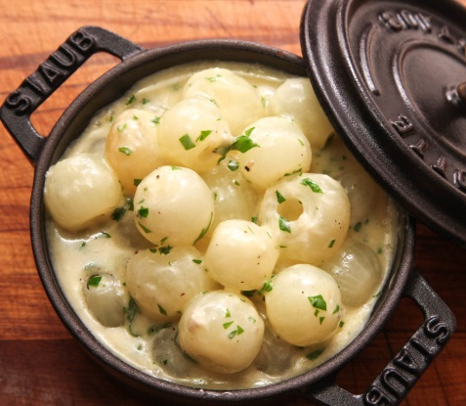
COOK TIME
Prep | 10 m
Cook | 20 m
Ready In | 30 m

INGREDIENTS
2 pounds pearl onions (see note above)
1 cup heavy cream
1/2 cup homemade or store-bought low-sodium chicken stock
1 bay leaf
Kosher salt and freshly ground black pepper
2 tablespoons finely chopped fresh parsley leaves
DIRECTIONS
Using a paring knife, trim off the ends of each onion and score a light "X" into one cut side. Bring a medium pot of water to a boil over high heat. Add onions and cook until outer layers are soft, about 1 1/2 minutes. Drain onions and run under cool water until cold enough to handle. Peel onions with your fingers and discard peels.
Place onions in a medium saucepan and add heavy cream, stock, and bay leaf. Heat over medium-high heat until simmering, then lower heat to maintain a very gently simmer. Cook, stirring occasionally, until cream has reduced to a rich sauce, about 20 minutes. Season to taste with salt and pepper, discard bay leaf, stir in parsley, and serve. If sauce breaks and turns greasy, stir in 2 tablespoons of water and shake pan vigorously over high heat until it comes back together.

