 | MASHED POTATOES
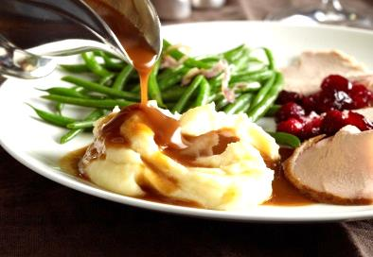
 |  | COOK TIME
 |  | Prep | 1 hr
 |  | Cook | 30 m
 |  | Ready In | 1 hr 30 m
INGREDIENTS
 | 3 pounds Yukon gold potatoes
 | 2 teaspoons salt, divided
 | 1/3 cup butter
 | 1/3 cup half-and-half
 | 4 ounces cream cheese, softened
 | 3/4 teaspoon coarsely ground pepper
DIRECTIONS
Peel, Boil & Drain.
Peel potatoes, and cut into 1-inch pieces. Bring potatoes, 1 tsp. salt, and cold water to cover to a boil in a medium-size Dutch oven over medium-high heat. Reduce heat to medium-low, and cook 16 to 20 minutes or until fork-tender; drain.
Add Creamy Richness.
Return potatoes to Dutch oven. Cook until water evaporates and potatoes look dry. Mound potatoes on 1 side; add butter, next 3 ingredients, and remaining 1 tsp. salt to opposite side of Dutch oven. Cook 1 to 2 minutes or until butter is melted and mixture boils.
Beat Until Smooth.
Remove from heat; beat at medium speed with a hand-held electric mixer 30 seconds to 1 minute or to desired degree of smoothness. (Do not overbeat.) Serve immediately

