MASHED TURNIP
COOK TIME
Prep | 10 m
Cook | 35 m
Ready In | 45 m

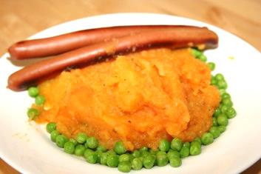
INGREDIENTS
7 large turnips
1 cup milk
2 tablespoons butter
salt to taste
ground black pepper to taste
DIRECTIONS
Peel, wash, and quarter turnips.
Boil 35-45 minutes or until tender. Strain and rinse cooked turnips.
Place in large mixing bowl and use fork to break up turnips into smaller bits. Add milk and butter. Blend to desired consistency. Add salt and pepper to taste.

