 | NEW ENGLAND CHESTNUT STUFFING
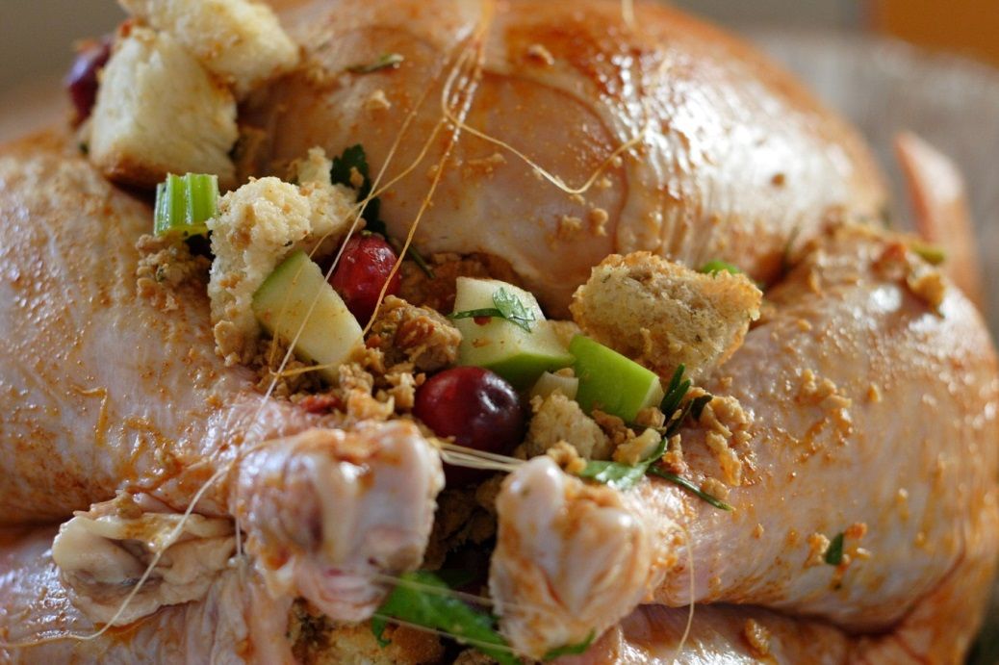 |  | COOK TIME
 |  | Prep | 30 m
 |  | Cook | 1 hr 25 m
 |  | Ready In | 2 hr 5 m
 | INGREDIENTS
 | STUFFING
 | 1 1/2 1-pound loaves old-fashioned white bread, cut into 1/2-inch cubes (about 16 cups)
 | 1/2 cup (1 stick) butter
 | 3 large onions, chopped
 | 1 pound mushrooms, sliced
 | 5 celery stalks, chopped
 | 1 1/2 pounds fresh chestnuts, roasted, shelled, chopped (about 3 cups) or 3 cups steamed chestnuts in jar, very coarsely chopped (about 15 ounces)
 | 1/4 cup chopped fresh thyme or 2 teaspoons dried
 | 3 tablespoons chopped fresh rosemary or 2 teaspoons dried
 | 1/2 teaspoon ground nutmeg
 | 1 1/2 cups (about) canned low-salt chicken broth
 | DIRECTIONS
 | Preheat oven to 400°F. Divide bread between 2 large baking sheets. Bake until golden, stirring occasionally, about 25 minutes. Transfer to large bowl.
 | Melt butter in heavy large skillet over high heat. Add onions and cook until golden brown, stirring occasionally, about 20 minutes. Reduce heat to medium. Add mushrooms; stir until mushrooms begin to soften and release juices, about 5 minutes. Add celery and stir 2 minutes. Mix contents of skillet into bread cubes. Mix in chestnuts, thyme, rosemary and nutmeg. Season to taste with salt and pepper. (Can be prepared one day ahead. Cover and refrigerate.)
 | TO bake stuffing in turkey:
 | Mix 1/2 cup chicken broth into stuffing. Fill main turkey cavity with stuffing. Mix enough chicken broth into remaining stuffing to moisten (about 1/2 to 3/4 cup chicken broth, depending on amount of remaining stuffing). Spoon remaining stuffing into buttered baking dish. Cover stuffing with buttered aluminum foil. Bake stuffing in a dish alongside turkey until heated through, about 45 minutes.
 | To bake all stuffing in pan:
 | Preheat oven to 350°F. Butter 15x10x2-inch baking dish. Mix 1 1/2 cups broth into stuffing. Transfer to prepared dish. Cover with buttered foil. Bake until heated through, about 1 hour 15 minutes.

