 | ROASTED PUMPKIN PIE
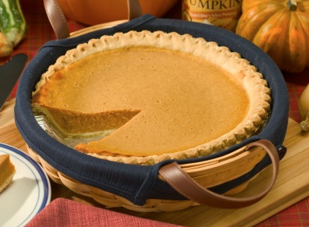 | COOK TIME  Prep 15 m  Inactive 2 hr 30 m  Cook 1 hr 5 m  Ready In 3 hr 50 m
INGREDIENTS
 | Crust:
 | 6 ounces gingersnap cookies
 | 1 tablespoon dark brown sugar
 | 1 teaspoon ground ginger
 | 1 ounce unsalted butter, melted
 | Filling:
 | 16 ounces Pumpkin Puree, recipe follows
 | 1 cup half-and-half
 | 1/2 teaspoon freshly grated nutmeg
 | 1/2 teaspoon kosher salt
 | 3/4 cup dark brown sugar
 | 2 large eggs
 | 1 large egg yolk
 | Brulee for mini-pies:
 | 5 teaspoons light brown sugar, divided
 | Pumpkin Puree:
 | 1 (4 to 6-pound) baking pumpkin, rinsed and dried
 | Kosher salt
DIRECTIONS
Brulee for mini-pies:
 | Heat the oven to 350 degrees F.
 | For the crust: Combine the gingersnaps, brown sugar, and ginger in the bowl of a food processor. Process until the cookies are fine crumbs. Drizzle the butter into the crumb mixture. Pulse 8 to 10 times to combine.
 | Press the gingersnap mixture into the bottom, up the sides, and just over the lip of a 9-inch glass pie dish. Place on a half sheet pan and bake the crust for 10 to 12 minutes. Cool crust at least 10 minutes before filling.
 | For the filling: Bring the pumpkin puree to a simmer over medium heat in a 2-quart saucepan. Cook, stirring occasionally, until slightly thickened, 2 to 3 minutes. Add the half-and-half, nutmeg, and salt. Stir and return the mixture to a simmer. Remove the pumpkin mixture from the heat and cool for 10 minutes.
 | Whisk the brown sugar, eggs, and yolk until smooth in a large bowl. Add the pumpkin mixture and whisk until thoroughly combined. Pour the prepared filling into the warm pie crust and bake on the same half sheet pan until the center jiggles slightly but the sides of the filling are set, 45 to 50 minutes. Cool on a cooling rack for at least 2 to 3 hours before slicing. Pie can be made and refrigerated up to 2 days in advance. Pie is best the day after it is made.
 | For mini-pies: Evenly divide the crust mixture between 5 (5-inch) pie tins and bake on a half sheet pan for 5 minutes. Cool for 10 minutes before evenly dividing the filling between the pans. Bake until the center juggles slightly but the sides of the filling are set, 25 minutes. Cool on a cooling rack for 2 hours. Spread 1 teaspoon of light brown sugar on the top of each pie. Melt the sugar using a torch to form a crispy top. Cool for 5 minutes before serving.
Pumpkin Puree:
 | Heat the oven to 400 degrees F.
 | Slice a small piece of skin off the one side of the pumpkin so when laid on its side, the pumpkin will lay flat without rolling. Remove the stem and split the pumpkin in half from top to bottom, using a large cleaver and a mallet. Scoop out the seeds and fiber with a large metal spoon or ice cream scoop. Cut the fibers with kitchen shears if necessary. Reserve seeds for another use.
 | Sprinkle the flesh with kosher salt and lay the halves, flesh side down, on a parchment paper-lined half sheet pan. Roast until a paring knife can be easily inserted and removed from the pumpkin, 30 to 45 minutes. Test in several places to ensure doneness.
 | Remove the half sheet pan to a cooling rack and cool the pumpkin for 1 hour. Using a large spoon, remove the roasted flesh of the pumpkin from the skin to the bowl of a food processor. Process until the flesh is smooth, 3 to 4 minutes. Store in the fridge for up to 1 week or freeze for up to 3 months.

